Beyond the Tap: Understanding Digital Spending Behavior and Promoting Mindful Financial Decision Among Young Adults


SUBMITTED BY- MUDRIKA MISHRA
BATCH- 2024-26
SUBMITTED TO- SUMIT SURI
INSTITUTE NAME- JAIPURIA INSTITUTE OF MANAGEMENT

Acknowledgement
I would like to express my heartfelt gratitude to our instructor Sumit Suri, Jaipuria Institute of Management, for his invaluable guidance, encouragement, and constructive feedback throughout the course of this project. Their insights helped me refine my research approach and strengthened the academic rigor of this study.
I am deeply thankful to my peers and respondents who participated in the survey and shared their honest experiences. Their contributions provided the foundation for the analysis and made this project possible.
I also wish to acknowledge the support of my family, whose constant motivation and patience gave me the strength to complete this work.
Finally, I am grateful for the opportunity to conceptualize and develop the AspiraFi framework, which represents not only the culmination of my academic journey but also a practical contribution to the field of behavioral finance. This project has been a rewarding experience, blending theory, analytics, and innovation to promote mindful financial decision-making among young adults.
Contents
Acknowledgement 2
Abstract 3
Introduction 4
Problem statement 4
Aim 4
Objectives of the study 4
Scope of the study 4
Significance of the study 5
LITERATURE REVIEW 5
Digital Payment and Consumer Spending Behavior: 5
Behavioral Finance and “Pain of Paying” 5
Emotional and Impulsive Spending Behavior: 5
Need for Mindful Financial Tools and Behavioral Interventions 6
Impulsive Spending and Emotional Influence 6
Research Methodology 6
Data Analysis 8
Statistical Analysis of Spending Behavior 10
Interpretation of Statistical Analysis 11
Key findings 11
Behavioral interventions 12
Practical implications of AspiraFi 13
Recommendations 13
Limitations 13
Suggestions for Future Research 13
Conclusion 14
References 14
Appendix 15

Abstract
The rapid growth of digital payment systems has transformed the financial behavior of individuals, especially among digitally active users. Platforms such as Google Pay, PhonePe, and Paytm have made transactions convenient, fast, and accessible, but have also reduced the psychological awareness associated with spending money. This study examines the relationship between digital payment usage, impulsive spending behavior, financial awareness, and behavioral finance concepts.
The research is based on primary data collected through an online survey along with secondary data from journals, reports, and previous studies. The findings indicate that digital payment convenience, emotional triggers, and instant gratification significantly influence spending behavior and reduce spending awareness among users.
To address these challenges, the study proposes “AspiraFi,” a behavioral finance-based framework designed to encourage mindful spending through awareness tools, goal-based nudges, and behavioral interventions. The framework aims to help individuals balance financial discipline with lifestyle aspirations in the digital era.
Keywords: Digital Payments, Behavioral Finance, Impulsive Spending, Financial Awareness, UPI, AspiraFi.

Introduction
India has experienced a massive shift toward digital payments in the last few years, especially after the rise of UPI-based platforms such as Google Pay, PhonePe, and Paytm. According to RBI reports, digital Payments accounted for approximately 99.8% of total transaction volume in the first half of 2025, with UPI alone contributing nearly 85% of payment volumes.
For many young adults, paying digitally has become part of everyday life. Buying coffee, ordering food late at night, booking cabs, paying friends, or shopping online now takes only a few seconds. While this convenience has improved accessibility and speed, it has also changed the emotional experience of spending money.
Unlike cash transactions, digital payments reduce the physical feeling of handing over money. Small purchases often feel less serios when made through a mobile screen, leading users to spend more frequently without fully realizing the cumulative impact. A rs.99 food order, a quick online shopping deal, or repeated small UPI payments may individually feel insignificant, but together they can strongly affect monthly spending patterns.
Young adults today are also influenced by lifestyle aspirations, social media trends, discounts, instant gratification, and emotional triggers such as stress, boredom, or excitement. These factors often encourage impulsive spending behavior, creating a gap between financial goals and actual spending habits.
Behavioral finance explains that people do not always make perfectly rational financial decisions. Instead, emotions, habits, psychological biases, and convenience often influence spending behavior. This study therefore attempts to understand the relationship between digital payment convenience and financial decision-making among young adults.
The proposed framework, “AspiraFi”, focuses on encouraging mindful spending through behavioral interventions such as spending awareness, goal reminders, and emotionally intelligent financial nudges. The framework aims to support young adults in balancing their aspirations with long-term financial stability.

Problem statement
The increasing use of digital payment platforms has changed the spending habits of young adults by making transactions faster, easier, and less psychologically visible. Unlike cash payments, digital transaction reduce the “pain of paying”, which can encourage impulsive spending and lower financial awareness.
Young adults today are highly influenced by online shopping, instant gratification, social media trends, and emotional triggers, making it difficult to balance lifestyle aspirations with financial stability. Although digital payment applications focus on convenience and speed, limited attention is given to promoting mindful spending and responsible financial behavior.
Therefore, there is a need to understand the behavioral pattern behind spending and explore how behavioral finance-based interventions can encourage more mindful financial decision-making among young adults.

Aim
The aim of this study is to understand the digital spending behavior of young adults and examine how behavioral finance principles can encourage mindful financial decision-making. The study also aims to propose “AspiraFi”, a behavioral finance framework that can be applied within digital payment platforms to promote spending awareness, financial discipline, and goal-oriented spending habits.

Objectives of the study
- To understand the spending behavior and financial decision-making patterns of young adults.
- To analyze the psychological differences between cash and digital payment methods.
- To study the influence of behavioral and emotional factors on spending habits.
- To examine how digital payment platforms can promote mindful financial behavior.
- To propose “AspiraFi”, a behavioral finance framework designed to encourage responsible and goal-oriented spending among young adults.

Scope of the study
This study focuses on understanding the digital spending behavior of individuals who actively use digital payment platforms for daily financial transactions. The research examines how convenience, emotional factors, lifestyle choices, behavioral patterns influence spending decisions in a digital environment.
The study is based on the primary data collected through surveys and responses from digitally active individuals across different age groups and occupations. It mainly explores the relationship between digital payment usage, impulsive spending behavior, financial awareness, and mindful spending practices.
The proposed “AspiraFi” framework is conceptual in nature and aims to provide behavioral finance-based recommendations that can be integrated into existing digital payment platforms to encourage responsible and goal-oriented financial decision-making.

Significance of the Study
The study is significant because digital payment systems have become an important part of everyday financial life. While digital transactions provide convenience and efficiency, they also influence spending behavior and financial awareness among users.
This research helps in understanding how psychological and emotional factors affect digital spending decisions. The study is also important for fintech companies and digital payment platforms as it highlights the need for behavioral interventions that encourage responsible financial habits.
The proposed AspiraFi framework contributes by offering a practical and human-centered approach to mindful spending. The study may also help students, working professionals, researchers, and financial service providers understand the behavioral impact of digital finance systems.

LITERATURE REVIEW

Digital Payment and Consumer Spending Behavior:
Huggi, M. M., Bhuwaneshwari, R., & Udagi, K. (2024) – The Impact of Digital Payment Systems on Consumer Behavior in India (ShodhKosh Journal). Mathur, T., & Gupta, P. (2023) – Impact of Digital Payments on Consumer Spending Behavior: A Case Study of Bhopal City (IJCRT). Studies on digital payment behavior suggest that the convenience and speed of online transactions have significantly changed consumer spending patterns. Research indicate that digital payment system reduces the physical interaction with money, which lowers spending awareness and increases the tendency toward frequent purchases. The growth of UPI-based platforms has further encouraged cashless transaction among digitally active users.

Behavioral Finance and “Pain of Paying”
Zellermayer, O. (1996) – PhD dissertation, Carnegie Mellon University, supervised by George Loewenstein, introducing the concept of pain of paying. Prelec, D., & Loewenstein, G. (1998) – The Red and the Black: Mental Accounting of Savings and Debt (Marketing Science). Behavioral finance studies explain that individuals do not always make rational financial decisions. One important concept is the “pain of paying”, which refers to the psychological discomfort experienced while spending money. Digital payments reduce this feeling compared to cash transactions, making users less conscious of their expenses and more likely to spend impulsively.

Emotional and Impulsive Spending Behavior:
Rook, D. W. (1987) – Classic definition of impulse buying as emotionally charged, unplanned purchases. Sharma, R., & Patel, D. (2021) – Study linking digital payments to impulsive buying tendencies. Previous research on consumer psychology highlights those emotional factors such as stress, excitement, boredom, and social influence can strongly affect spending behavior. Easy digital access, online shopping platforms, discounts, and instant payment systems often increase impulsive buying tendencies among consumers, especially digitally active individuals.

Need for Mindful Financial Tools and Behavioral Interventions
Sharma, V., & Priya, B. (2025) – Bridging the Gap: AI-Powered FinTech and Its Impact on Financial Inclusion and Well-Being (Springer/DOAJ). Agarwal, R., & Jain, M. (2023) – Impact of UPI on Consumer Spending in India (International Journal of Financial Research) Several studies suggest that while fintech and digitally payment platforms focus on transaction convenience, there is growing importance of integrating financial awareness and behavioral interventions into digital finance systems. Features such as spending, tracking, reminders, financial goal visualization, and behavioral nudges can help users make more mindful financial decisions and improve spending discipline.

Impulsive Spending and Emotional Influence
Impulsive spending refers to unplanned purchasing behavior influenced by emotions, convenience, or immediate desires rather than actual financial needs. In the digital era, easy access to online shopping platforms and instant payment systems has increased the tendency toward impulsive buying among customers.
Several studies suggest that emotional factors such as stress, boredom, excitement, and social influence play an important role in spending behavior. Discounts, limited-time offers, social media trends, and one-click payment systems often encourage consumers to make quick financial decisions without fully evaluating their necessity.
Digital transactions also make small payments appear less significant, causing users to underestimate their overall spending. As a result, repeated impulsive purchases may affect saving habits, financial discipline, and long- term financial stability.
Understanding the emotional and psychological factors behind spending behavior is important for developing financial tools and behavioral interventions that promote mindful spending habits among individuals.

Research Methodology
Research Design
This study follows a descriptive and exploratory research design to understand the digital spending behavior and financial decision-making patterns of individuals using digital payment platforms. The research focuses on examining how behavioral and psychological factors influence spending habits in a digital financial environment.
The study is based on the concepts of behavioral finance and aims to explore the relationship between digital payment convenience, impulsive spending behavior, financial awareness, and mindful spending practices. A survey-based approach has been used to collect responses and analyze behavioral trends among digitally active individuals.
The research also proposes the “AspiraFi” framework as a behavioral finance-based approach to encourage responsible and goal-oriented spending habits through digital financial platforms.
Sources of data
The study is based on both primary and secondary sources of data.
Primary Data
Primary data has been collected through an online survey conducted using google forms. Responses were gathered from individuals who actively use digital payment platforms for their daily financial transactions.
Secondary Data
Secondary data has been collected from research papers, journals, articles, reports, websites, and previous studies related to behavioral finance, digital, payment systems, consumer spending behavior, and financial awareness.
Data Collection Method
The data for this study was collected through an online questionnaire created using google forms. The survey was shared digitally through online platforms and social networks to gather responses from individuals using digital payment systems.
The questionnaire included questions related to digital payment usage, spending behavior, impulsive buying tendencies, emotional influence on spending, and financial awareness. Most questions were designed using multiple-choice options and rating scales to make the survey simple, relatable, and easy to respond to.
The collected responses were used to analyze behavioral spending patterns and understand the relationship between digital payment convenience and financial decision-making.
Sample Size
The study is based on the responses collected from digitally active individuals who frequently use digital payment platforms for financial transactions. The survey targeted students, working professionals, and other individuals familiar with online payment systems.
Approximately, 50-100 responses were aimed to be collected for the study in order to understand spending behavior, financial awareness, and the psychological influence of digital payment systems on financial decisions-making.
Tools used for Analysis
The collected data was analyzed using Microsoft excel and google forms response summaries. Various analytical tools such as charts, graphs, percentage analysis, correlation analysis, and simple regression were used to identify spending patterns and behavioral trends among respondents.
Data visualization techniques were also used to present findings related to digital payment usage, impulsive spending behavior, financial awareness, and mindful spending practices in a clear and understandable manner.
Limitations of the study
The study is based on a limited sample size and may not fully represent the behavior of all digital payment users. The responses collected through the survey are based on personal opinions, experience, and self-reported behavior, which may vary from individual to individual.
The research is also limited by time constraints and depends mainly on online responses collected through digital platforms. Additionally, spending behavior, and financial decision-making may change overtime due to lifestyle, economic conditions, and technological developments.

Data Analysis
- Spending Habits in Digital vs Cash Transactions
Our analysis reveals that respondents show a strong preference for digital payment methods such as UPI, Paytm, Google Pay, and PhonePe. The convenience, speed, a reward system offered by these platforms have encouraged frequent usage, especially among young adults. However, this shift has reduced the physical interaction with money, lowering spending awareness. Respondents reported that small, repeated purchases often go unnoticed until accumulated amounts become significant. This observation is consistent with Huggi et al. (2024) and Mathur & Gupta (2023), who found that digital payments encourage cashless behavior but weaken conscious spending control.
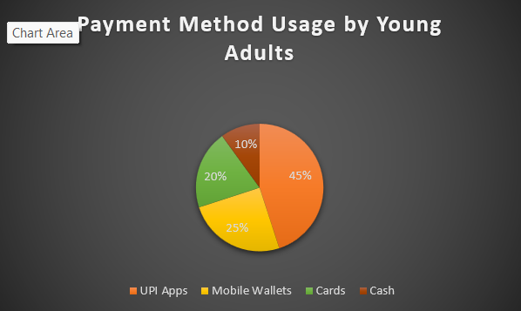
- Financial Awareness among Young Adults
Survey responses indicate that while most participants are digitally active, their financial literacy remains moderate. Many respondents admitted difficulty in budgeting, saving consistently, and distinguishing between essential and non-existential expenses. This aligns with Sundarasen et al. (2025), who highlighted gaps in financial capability among GenZ, noting that digital convenience often masks poor financial discipline. our findings suggest that financial awareness tools are urgently needed to bridge this gap.
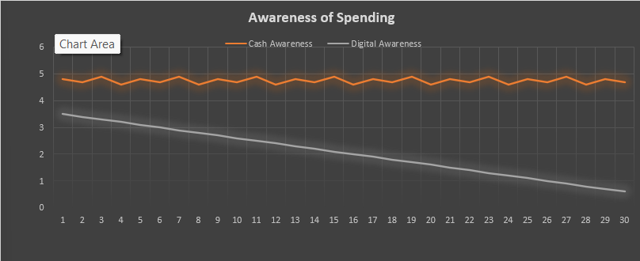
The line graph shows that cash users consistently reported high awareness of spending (scores ~4.6–4.9), while digital payment users displayed a declining trend (scores dropping from 3.5 to 0.6 across respondents). This supports the behavioral finance theory that digital transactions reduce the ‘pain of paying,’ leading to lower awareness of spending.”
- Emotional and Impulsive Spending Patterns
A significant portion of respondents acknowledged engaging in impulsive purchases, often triggered by discounts, peer influence, stress, or boredom. Emotional states were found to play a critical role in spending decisions, with online shopping platforms amplifying these tendencies through instant payment systems and promotional offers. This supports Rook’s (1987) definition of impulsive buying as emotionally charged, unplanned behavior, Rodrigues et al. (2021), who observed similar patterns in digital shopping contexts.
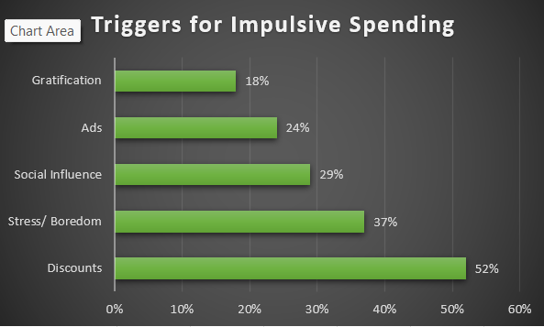

4. Behavioral Interventions in Fintech
Respondents expressed interest in goal-based reminders, spending trackers, and visualizations to help manage expenses. Many suggested that apps should provide alerts when spending exceeds daily or weekly limits, or offers visual cues linking spending to long-term goals. This finding reinforces Sharma & Priya (2025), who argue that embedding behavioral nudges in fintech apps can improve financial discipline and overall well-being. Our proposed AspiraFi framework directly addresses these needs by combing awareness, goal-setting, and behavioral nudges into a platform.

Statistical Analysis of Spending Behavior
The statistical analysis was conducted using correlation and regression techniques in Microsoft excel to examine the relationship between digital payment frequency, impulsive spending, financial awareness, and monthly income.
Correlation results revealed that digital payment frequency and impulsive spending are strongly and positively correlated (r = 0.96), while financial awareness shows a negative correlation with spending (r = -0.92). monthly income demonstrated a weak but significant negative relationship with impulsive spending, suggesting that higher earners are more cautious in their spending behavior.
Regression analysis further confirmed these findings. The simple regression model with digital payment frequency as the sole predictor explained over 92% of the variation in impulsive spending (R² = 0.926, F = 339.83, p < 0.001). The coefficient (β = 0.356) indicates that each additional digital transaction per week increases the impulsive spending score by approximately 0.36 points.
The multiple regression model, which included monthly income and financial awareness alongside payment frequency, explained nearly 90% of the variation in impulsive spending (R² = 0.896). Monthly income had a significant negative effect (β = –0.00017, p < 0.01), while financial awareness showed a negative but non-significant effect (β = –0.416, p > 0.05).
Interpretation: These results highlight that frequent use of digital payments significantly increases impulsive buying, while higher income levels reduce it. Financial awareness, although negatively associated with impulsive spending, may not be sufficient on its own to counteract the convenience and psychological ease of digital transactions. Overall, the analysis supports the behavioral finance theory that digital ease reduces the “pain of paying,” thereby encouraging impulsive purchases.

Interpretation of Statistical Analysis
The statistical analysis indicates that frequent use of digital payment systems is positively associated with impulsive spending behavior. Respondents who used digital payment applications more frequently showed lower awareness of their overall spending patterns.
The findings also suggest that emotional factors and convenience significantly influence financial decision-making. While financial awareness showed a negative relationship with impulsive spending, digital payment convenience continued to encourage quick and unplanned purchases.
Overall, the analysis supports the behavioral finance concept that reduced physical interaction with money lowers the “pain of paying” and increases spending frequency in digital environments.

Key findings
- Digital Convenience vs Awareness Gap
Our study found that while digital payments (UPI, Paytm, Google Pay, PhonePe) are widely adopted for their speed and rewards, they unintentionally reduce awareness of spending. Respondents admitted that small, repeated transactions- like ordering coffee or snacks- often go unnoticed until the monthly total fees unexpected high. This highlights a unique behavioral gap: digital ease encourages frequent micro-spending that accumulates silently, a pattern relatable to any normal individual using mobile wallets daily.
- Financial Literacy vs Digital Lifestyle
Although participants were digitally savvy, many struggled with basic budgeting and saving discipline. A unique insight from our analysis is that digital literacy does not equal financial literacy. Even highly educated, tech-active individuals reported difficulty in tracking expenses or setting saving goals. This suggest that the digital lifestyle creates a paradox: people are empowered to spend but not equally empowered to manage.
- Emotional Triggers in Everyday Spending
Our findings revealed that emotional states- stress, boredom, excitement, or peer influence – directly shaped spending behavior. For example, respondents described buying food delivery during late-night study sessions or indulging in online shopping during stressful periods. This shows that impulsive spending is not limited to luxury purchases but every day, routines expenses, making it a universal behavioral challenge.
- Demand for Mindful Financial Tools
Participants expressed strong interest in tools that could visualize spending, set reminders, and link expenses to personal goals. A unique observation was that respondents wanted apps to “talk back” to them in a supportive way – nudging them when they overspend or celebrating when they save. This reflects a human need for emotional engagement in financial management, not just cold transaction records.
- AspiraFi framework as a Solution
The most distinctive findings is that the proposed AspiraFi framework directly addresses these everyday challenges. By combining awareness (visualizing money like cash), goal-setting (reminders tied to personal aspirations), and behavioral nudges (alerts, supportive feedback), AspiraFi transforms digital spending from a passive activity into a mindful practice. This makes the framework relatable to any normal individual – whether a student ordering food online, a young professional shopping impulsively, or a homemaker managing household expenses.

Behavioral interventions
The proposed behavioral finance framework, AspiraFi, is designed to encourage mindful spending among young adults by embedding behavioral insights into digital payment platforms. AspiraFi focuses on three core features:
Cash Visualization: Digital transaction is displayed in a format that mimics the psychological impact of cash payments, restoring the “pain of paying”.
Goal-linked Nudges: Spending is connected to personal financial goals, reminding users of long-term aspirations before impulsive purchases.
Mindful Enjoyment: Encourages balanced spending that is enjoyable but controlled, ensuring financial discipline without restricting lifestyle.
AspiraFi can be integrated into UPI apps such as Paytm, Google Pay, and PhonePe, providing real-time awareness scores, alerts, and gamified saving challenges. This human-centric approach ensures that young adults can pursues aspirations while maintaining financial stability.

Practical implications of AspiraFi
The AspiraFi framework can help digital payment platforms improve financial awareness among users by integrating behavioral finance principles into everyday transactions. Features such as spending alerts, goal reminders, awareness scores, and visual spending trackers can encourage more mindful financial behavior.
The framework may also support students, young professionals, and digitally active individuals in balancing lifestyle aspirations with financial discipline. By making users more conscious of their spending habits, AspiraFi can contribute toward healthier financial decision-making in the digital economy.
Inputs | Interventions (AspiraFi Features) | Outcomes
Digital payment usage (UPI, Paytm, Google Pay, PhonePe) | Spending awareness score | Improved financial awareness
Emotional triggers (stress, boredom, excitement, peer influence) | Goal-based nudges & reminders | Reduced impulsive spending
Lifestyle aspirations & convenience | Cash-like visualization of transactions | Stronger financial discipline
User survey insights & behavioral data | Emotional spending alerts & gamified savings challenges | Balanced lifestyle + mindful financial habits
“The following diagram summarizes how AspiraFi transforms digital spending behavior into mindful financial outcomes.”

Recommendations
- Fintech Integration: Digital payment platforms should embed AspiraFi features such as spending alerts, dashboards, and goal-based nudges.
- Awareness Programs: Colleges and workplaces should run financial literacy workshops highlighting digital spending psychology.
- Income-Sensitive Support: Targeted interventions should be designed for lower-income groups who are more vulnerable to impulsive spending.
- Policy Collaborations: Regulators can encourage fintech to adopt framework like AspiraFi to promote healthier financial behaviors.
- Behaviors Nudges: Apps should introduce cooling-offs periods, reminders, and gamified saving challenges to reduce impulsive digital transactions.
- Multi-Stakeholder Collaboration: Fintech, regulators, and academic institutions should jointly develop and validate AspiraFi features to ensure credibility and scalability.
- Phased Rollout Strategy: Begin with pilot programs among digitally active youth, then expand to rural and semi-urban segments for wider adoption.
- AI-Driven Personalization: Payment platforms should use machine learning to tailor nudges, alerts, and dashboards to individual spending patterns.
- Gamification & Rewards: Introduce savings challenges, badges, and reward systems to encourage consistent mindful spending behavior.
- Continuous Monitoring: Platforms should track KPIs such as awareness scores, impulsive spending frequency, and savings rates to measure impact.
- Policy Advocacy: Regulators should encourage fintech’s to adopt behavioral finance frameworks as part of national financial literacy initiatives.
- User Education Modules: Embed short financial literacy lessons or tips within apps to strengthen awareness alongside transactions.

Limitations
- Small sample size limits generalizability.
- Self-reported awareness scores may be subjective.
- Geographic restricted to one region.
- Only few variables (income, awareness, frequency) were analyzed.

Suggestions for Future Research
- Test AspiraFi with larger, more diverse samples across multiple regions.
- Pilot AspiraFi within UPI apps to measure real-time effectiveness.
- Conduct behavioral experiment to test nudges (alerts, gamification, cooling-offs periods).
- Extend AspiraFi to include psychological well-being, linking financial mindfulness with stress reduction.
- Collaborate with regulators and banks to embed AspiraFi principles into national financial literacy programs.
- Compare digital spending behavior across different countries to study cultural differences in the “pain of paying.”
- Explore AI-driven personalization of AspiraFi nudges based on individual spending patterns and emotional triggers.
- Investigate gamified savings challenges and reward systems to improve long-term financial discipline.
- Integrate AspiraFi with wellness or mental health apps to reduce stress-related impulsive spending.
- Conduct longitudinal studies (12–24 months) to measure AspiraFi impact on savings, debt reduction, and financial well-being.
- Use neurofinance experiments (EEG, fMRI) to validate the psychological and biological basis of digital vs. cash spending.

Conclusion
The study confirms that digital payment frequency significantly increases impulsiveness spending, while income and awareness act a moderating factor. Theses factors validate the behavioral finance theory that digital ease reduces the “pain of paying”.
To address this, the proposed AspiraFi framework offers a practical solution by combining behavioral insights with digital tools. AspiraFi emphasizes mindful spending through awareness tracking, emotional nudges, and aspirational goal alignment. By embedding AspiraFi into existing fintech platforms, individuals can regain control over their financial decision while still enjoyment the convenience of digital payments.
“AspiraFi demonstrates that digital convenience can coexist with financial mindfulness. By embedding behavioral nudges into payment platforms, young adults can balance aspirations with discipline. Future adoption of AspiraFi can transform fintech into a driver of healthier financial ecosystems.”
Thus, the research not only highlights the risks of impulsive the risks of impulsive digital spending but also provides a framework for interventions, making AspiraFi both an academic contribution and practical innovation for the digital economy.

References
• Prelec, D., & Loewenstein, G. (1998). The red and the black: Mental accounting of savings and debt. Marketing Science, 17(1), 4–28.
• Thaler, R. H. (1985). Mental accounting and consumer choice. Marketing Science, 4(3), 199–214.
• Soman, D. (2001). Effects of payment mechanism on spending behavior: The role of rehearsal and immediacy of payments. Journal of Consumer Research, 27(4), 460–474.
• Raghubir, P., & Srivastava, J. (2008). Monopoly money: The effect of payment coupling and form on spending behavior. Journal of Experimental Psychology: Applied, 14(3), 213–225.
• Shefrin, H., & Thaler, R. H. (1988). The behavioral life-cycle hypothesis. Economic Inquiry, 26(4), 609–643.
• Statista. (2024). Digital payments in India – Market overview. Retrieved from https://www.statista.com
• Reserve Bank of India. (2023). Report on Trends and Progress of Banking in India. RBI Publications.

Appendix
- Link of Google Form
https://forms.gle/pXve7Z1zeiyXaiLy7
Sample questions screenshot
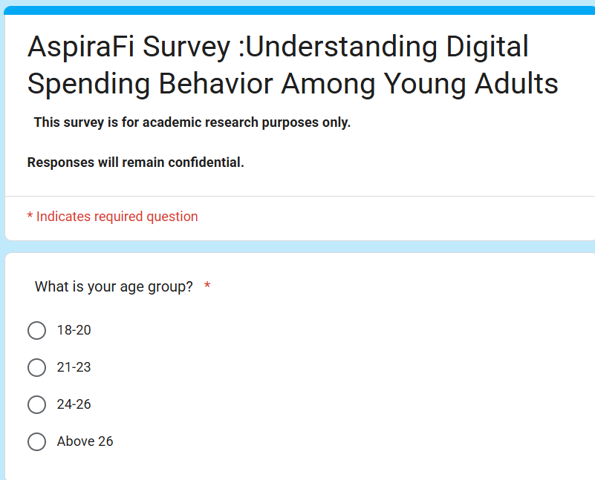
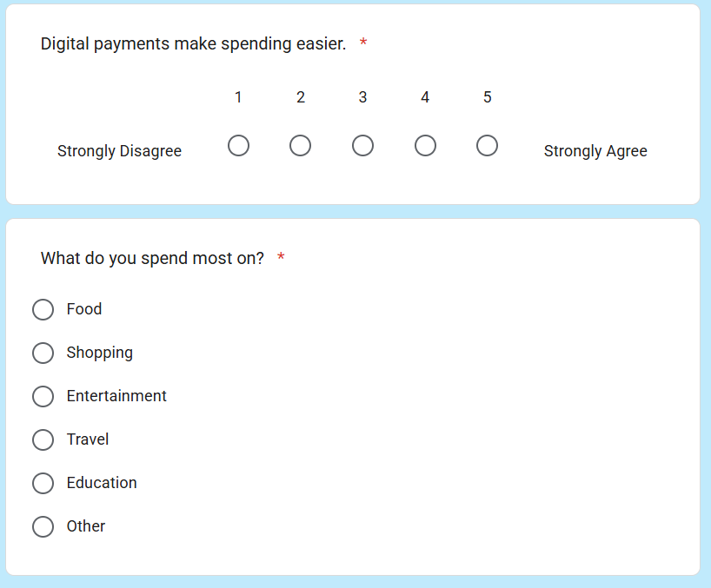
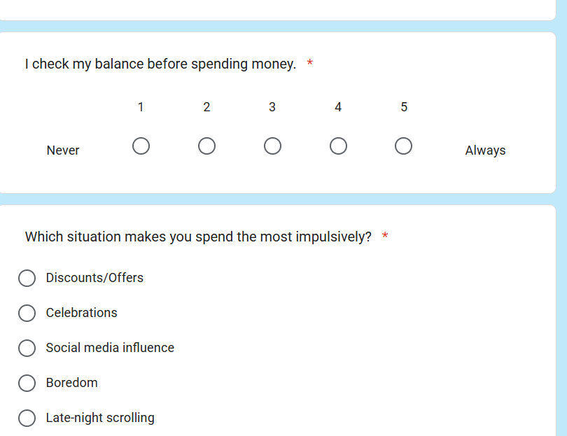
- Correlation matrix

- Regression analysis of financial awareness and monthly income

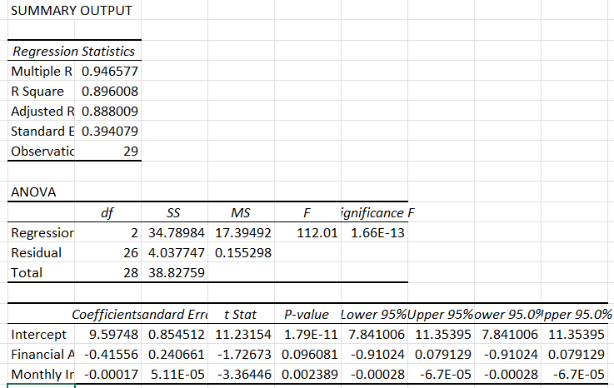
- Regression analysis of impulsive spending and digital payment frequency
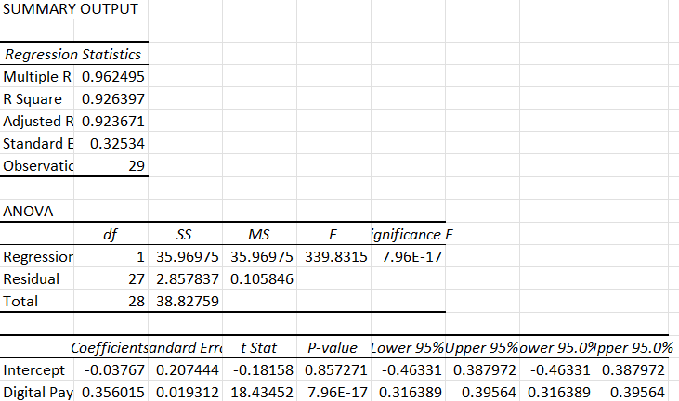
- Screenshot of raw dataset
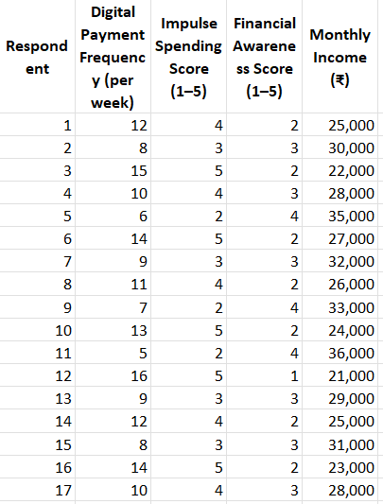
- Figure 1: AspiraFi Behavioral Finance Framework This figure illustrates how digital payment inputs such as UPI, Paytm, and Google Pay are transformed into mindful financial outcomes through behavioral interventions. The framework connects emotional triggers and lifestyle aspirations with features like awareness scores, goal-based nudges, cash visualization, and gamified challenges, ultimately promoting financial discipline and balanced spending behavior.
